To: Dr. Armin Eilaghi

CC: Connor Gaudette

From: Flying Squirrel

Date: 8/30/2025

Re: Project Management

**1. Reflection**

**Project Management - Success:**

The team was successful in many areas, mainly in client meetings and presentation organization. Some stand out points are included in the following list:

Client Meetings:

* Consistent
* Concept generation
* Prototyping
* Plans moving forward

Presentations:

* Well organized
* Quality information
* Shared input

**Project Management - Room for Improvements:**

While the team felt the semester was successful, there are areas the team can improve on. The following list highlights these areas of improvement.

* Time management
* Communication
* Assignment contribution
* Exclusive team meetings
* Seeking instructor/TA feedback on assignments

**Project Management - Action Items:**

The following list addresses the areas of improvements and how to resolve issues in the future.

1. **Time management**

* Start assignments sooner for all classes to avoid schedule conflicts and ensure high quality work

1. **Communication**

* Move from previous line of communication to more reliable resource such as teams, which will allow smoother work on online assignments

1. **Assignment contribution**

* Discuss with team members their role in specific assignments, making the best use of every team member’s capabilities

1. **Exclusive team meetings**

* Create a designated time for the team to meet to discuss assignments, progress, or any other issues

1. **Seeking instructor/TA feedback on assignments**

* Help improve overall grade on assignments

**Remaining Design Efforts:**

* Motor testing: Ensure motors can spin at the required RPM while producing the required torque.
* Learning Teensy: In our last client meeting, our client recommended using Teensy instead of Arduino as the chosen motors use CANBUS communication and Teensy functions better for that.
* Learn how to use 3D printers.
* Test each iteration and make corrections as needed.

**2. Gantt Chart**

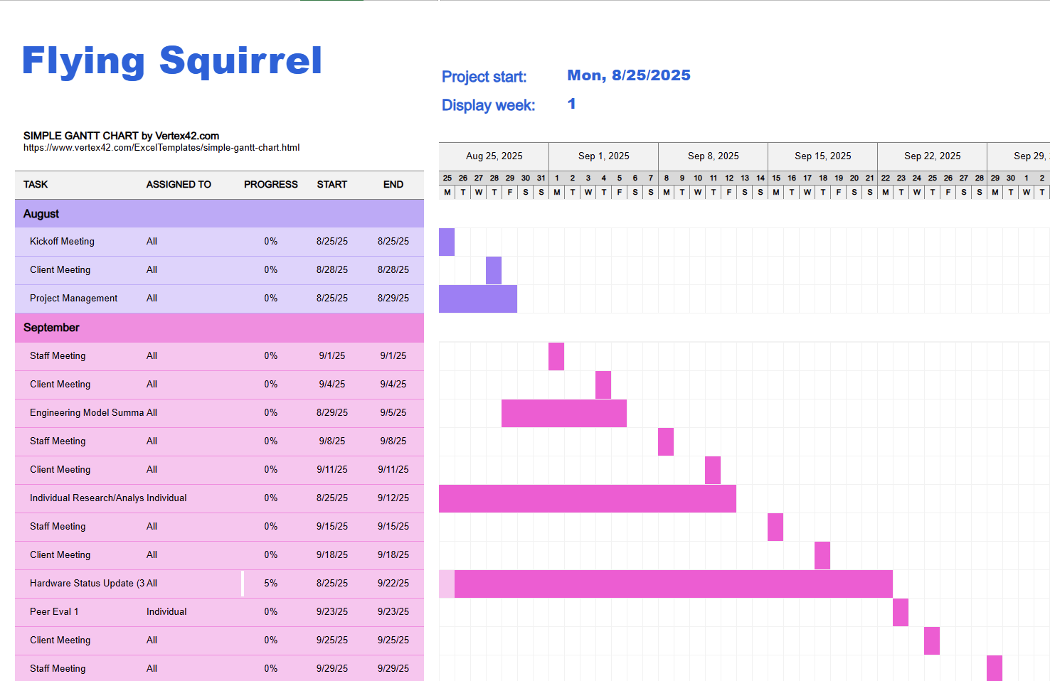

This chart breaks down the normal weekly tasks for our project as well as the deliverables required to keep on track. Our first major milestone will be the hardware check, which will be preceded by other smaller tasks. Working backwards, these steps will look something like this:

* Present first hardware status update (33%)
* Confirm updates with client and review feedback
* Assemble hardware
* Print or fabricate needed custom parts
* Order third party components
* Plan hardware demonstration
* Plan hardware/parts assembling progression with client
* Review final CAD model and drawings
* Finalize choices for outside components

**3. Top Level Finances**

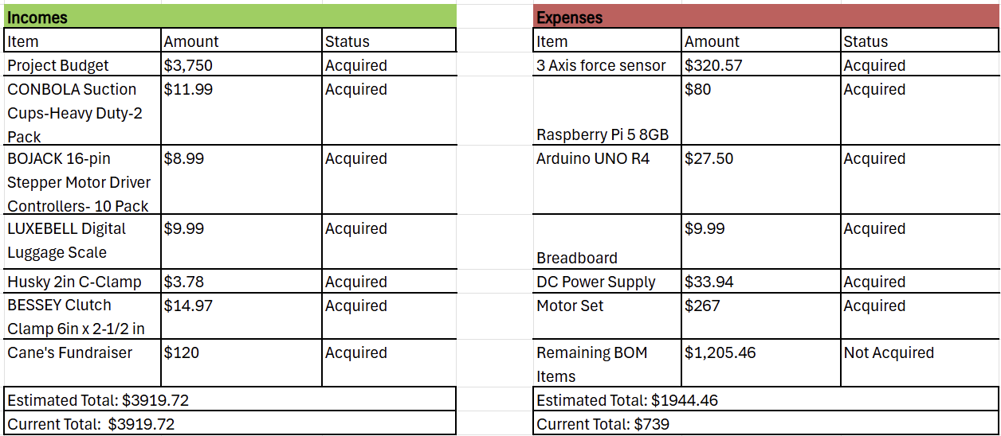

**4. Purchasing Plan**

|  |  |  |  |  |  |  |  |  |  |
| --- | --- | --- | --- | --- | --- | --- | --- | --- | --- |
|  | Raw Materials, Parts or Components | ($) Unit Cost | make/buy | Primary vender | Manufacturer | lead time | Part Status | QTY | ($) Total cost |
| 1 | 3 Axis force sensor | 320.57 | buy | zhimin | zhimin | Arrived | on hand | 1 | 320.57 |
| 2 | ODrive S1 | 59.00 | buy | Odriverrobotics | Odriverrobotics | 2 week | on order | 4 | 236 |
| 3 | 16384 CPR Absolute RS485 Encoder with Cable for ODrive Pro or S1 | 149 | buy | Odriverrobotics | Odriverrobotics | 2 week | on order | 4 | 596 |
| 4 | Dual Shaft Motor - D5312s 330KV | 59.00 | buy | Odriverrobotics | Odriverrobotics | 2 week | on order | 4 | 236 |
| 5 | PLA (1Kg) | 20.73 | buy | Amazon | creality | 2 days | on hand | 1 | 20.73 |
| 6 | Trapazoidal Lead Screws,10 x 2, RH steel 20 inches | 29.06 | buy | Roton | Roton | 1.5 weeks | 8/28/2025 | 2 | 58.12 |
| 9 | Trapazoidal Lead nut,10 x 2, RH Bronze | 25.79 | buy | Roton | Roton | 1.5 weeks | 8/28/2025 | 2 | 51.58 |
| 10 | 2x OVONIC 3S Lipo Battery 15000 mAh 130C 11.1V LIPO battery with EC5 plug for 1/8 RC truck | 126 | buy | ovonic | ovonic | 1 week | 8/28/2025 | 1 | 126 |
| 11 | Raspberry Pi 5 8GB | 80 | buy | electromaker | raspberrypi | Arrived | on hand | 1 | 80 |
| 12 | Arduino UNO R4 | 27.5 | buy | Amazon | ELEGOO | Arrived | on hand | 1 | 27.5 |
| 13 | Strap | 8.99 | buy | industrialsafety | industrialsafety | 1 week | 10/16/2025 | 1 | 8.99 |
| 14 | 6.5x3 touch LED screen | 0 | buy | waveshare | waveshare | 2 weeks | Donated | 1 | 0 |
| 15 | Ball bearings | 2 | buy | harborfreight | harborfreight | 3 days | 8/28/2025 | 3 | 6 |
| 16 | DC power supply | 33.94 | buy | Amazon | Nice-Power | 3days | Purchased | 1 | 33.94 |
| 17 | Suction cup | 12 | buy | Amazon | Airhead | 3 days | 10/16/2025 | 3 | 36 |
| 18 | Fishing line | 25 | buy | Amazon | Beyond Braid Braided | 3 days | 10/16/2025 | 1 | 25 |
| 19 | C-Clamp | 5 | buy | Home depot | Amerella | 3 days | 10/16/2025 | 3 | 15 |
| 20 | screws | 5 | buy | Home depot | Amerella | 3 days | 8/28/2025 | 1 | 5 |
| 21 | linear ball bearings | 5.83 | buy | misumi | misumi | 1 week | 10/16/2025 | 1 | 5.83 |
| 22 | Uxcell 10mm OD 8mm Inner Dia 400mm Length 6063 Aluminum Tube | 6.22 | manufactured | harfington | harfington | 1 week | 8/28/2025 | 1 | 6.22 |
| 23 | Breadboard | 9.99 | buy | Amazon | amazon | Arrived | on hand | 1 | 9.99 |
| 24 | mounts | 10 | buy | jameco | jameco | 1 week | 8/28/2025 | 3 | 30 |

We have bought one motor set with us and is undergoing testing before we purchase three more sets of the motors. We have also received a donated screen from Professor Reza.

**5. Manufacturing Plan**

Following the bill of materials and purchasing plan above, the remaining items planned for the project will need to be manufactured by the team or outsourced locally. Below is a table listing these parts, who will be manufacturing them, and the predicted turnaround time. The parts are also listed in order of importance and will be manufactured in that order. The aluminum components will be a priority to be manufactured early in the semester, or before the semester, if possible, so testing and adjustments can be completed. The shell will be the last item produced, as it is planned to only be added once the final product is completed.

|  |  |  |  |  |
| --- | --- | --- | --- | --- |
| Part | Material | Manufacturing Location | Manufacturer | Estimated Time |
| Bottom Mounting Plate/Skeleton | Aluminum | NAU Machine Shop | Shop Managers | ≤ 1 Week |
| Top Mounting Plate/Skeleton | Aluminum | NAU Machine Shop | Shop Managers | ≤ 1 Week |
| Rear Support Rod | Aluminum | NAU Machine Shop | Joey Mathews | ≤ 3 Hours |
| Robot Shell | PLA | Ryan Donnellan's House (3D Printer) | Ryan Donnellan | ≤ 1 Week |

The team is currently planning on starting assembly of the robot starting on the week of September 1st, with the motor components, to begin testing. The plan is to assemble the bottom of the robot so the motor systems can be thoroughly tested for all movement. Following this, the lift mechanism will be assembled to ensure the system is working as intended. This is planned to be completed early in the semester as well. The top section of the robot will be the last to be assembled soon after that, and the entire robot and all of its sub-systems will be assembled as soon as the top portion is completed. This plan ensures that the robot will be completed with enough time for proper testing and modifications.